Chapter 19, Problem 72.

A series-parallel connection of two two-ports is shown in Fig.19.119.
Determine the z parameter representation of the network.

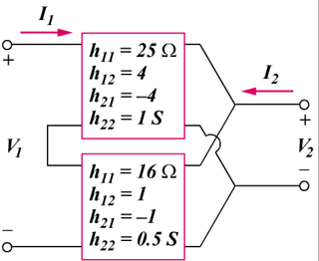

Figure 19.119
For Prob. 19.72.

